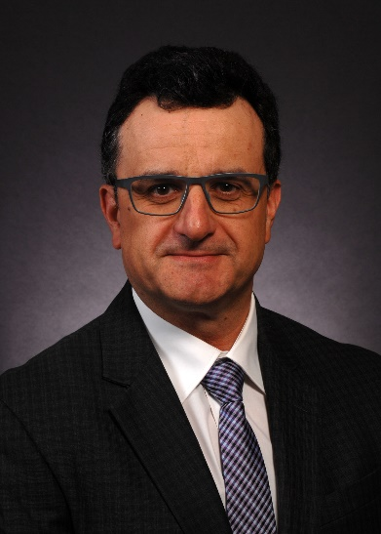

David Forbes is General Manager, Global Wells for ConocoPhillips and has 38 years industry experience, of which 33 years has been with ConocoPhillips in various drilling engineering, operations and management positions in the UK, Egypt, Dubai, China and Norway.

David also worked for Schlumberger in their Integrated Project Management Group in UK, Russia and Caspian Sea.

Prior to his current assignment, David was the Global Deepwater Drilling Manager based in Houston, responsible for ConocoPhillips deepwater drilling operations in the Gulf of Mexico and West Africa.

In 2016, David was promoted to General Manager, Global Wells and currently manages a team of technical experts supporting ConocoPhillips global drilling, completion and intervention operations.

David holds a Bachelor of Engineering degree in mechanical engineering from Liverpool University.

